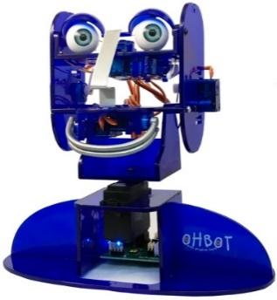
Year 4 - Lesson 2: Scaredy Eyes
Learning Intention
- I can program a robot to repeatedly move to random positions
Introduction
How did we make Ohbot move in the last lesson? We made Ohbot move a bit like us by using the pick random operator to make a random wait between movements. This week we are going to program Ohbot to look scared. We are going to program Ohbot to look around randomly.
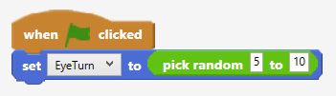
Teacher Input 1
Share the code with children and ask them to predict what they think will happen each time the green flag is clicked. Discuss how the code can be changed to make Ohbot move through the full range from 0 to 10.
Ask children to predict what the code will do.
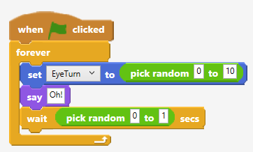
Activities
- Children copy the code. Challenge them to alter the random ranges to make Ohbot more relaxed or more nervous.
- Write a program to make other parts of Ohbot move randomly.
Extension
Experiment with the use of pick random. How many different ways can you use pick random to make Ohbot’s eyes move?

Plenary
Look at the code for the three random solutions. What do you think each will do? What is being changed randomly in each piece of code? A the time is random, B the distance moved is random and C the number of times the eyes move is random.

